BLUE BEACH HOTEL

Proposal Ref. No. 1-SDERFS

CONTENTS
ENTERPRISE BUSINESS PROPOSAL
Proposal Ref. No. 1-SDERFS

Company Overview 3
Our Strengths 5
Why with us 6
Your requirements 7
Proposed Solution 8
NETWORK ARCHITECTURE 8
SOLUTION DIAGRAM 9
Your Investment 10
OPTION: 1 10
OPTION: 2 10
OPTION: 3 10
Terms & Conditions 11
Customer Acknowledgements… 12
SME Solutions 13
Awards and Accolades 14
Contact us 15

ENTERPRISE BUSINESS PROPOSAL
Proposal Ref. No. 1-SDERFS
08 AUG 2025
IT Manager
Blue Beach Hotel
01,
Galle Road,
Colombo

Dear Sir/ Madam

Business Proposal for Blue Beach Hotel

We understand that every organisation needs to create an edge to succeed in the current complex business environment and how technology could help to achieve this. That is why we at SLT-MOBITEL, have created a suite of customisable and scalable intelligent enterprise solutions designed to help you make that crucial leap to take your business beyond where it can be to where it should be.
As we combine the strength of fixed and mobile, we pride ourselves on our unmatched enterprise capabilities and expert experience spanning for decades. Moreover, we have dedicated Account Managers at your service, ensuring we are not only your provider but also your partner in progress.
We are pleased to submit the attached proposal for Business Internet Line. Our proposal briefs on.
Business Internet lines are used by businesses to connect geographically distant offices. Unlike in other internet connections (dial-up/broad band), leased line provides customers with a committed internet bandwidth at a fixed monthly rate. While there are multiple ways of accessing the internet, broadband seems to be the most popular for internet access. But Business Internet Lines are preferred over broadband connections for providing internet connectivity to businesses like yours.
Dedicated internet solution is a business internet line (BIL) which offers direct unshared connectivity to internet. While there are many business broadband options available, internets leased lines are still preferred by most of the small & large businesses.

We look forward to discussing the proposal in detail. Do not hesitate to reach out to Samith Senevirathne on 0718765467 should you require any assistance.
We are committed to partnering with you in your journey to success and look forward to empowering your business with our intelligent business solutions.
Thank you Yours sincerely
…………………………………………………..

ENTERPRISE BUSINESS PROPOSAL

COMPANY OVERVIEW

SLT-MOBITEL, has been instrumental in inspiring the vision and growth of Sri Lanka’s economy and technological advancement as the national Information and Communications Technology (ICT) solutions provider. With the power of fixed and mobile, we provide a range of comprehensive tech driven products, services, and solutions to complement evolving digital lifestyles. We take pride in serving over nine million customers across the island through our high-speed fibre, copper, and mobile access networks. Furthermore, through our participation in international submarine cable systems, SLT-MOBITEL has connected Sri Lanka to the world, thereby creating numerous global opportunities.
Apart from fixed and mobile telephony, broadband, data services, and Internet Protocol Television (IPTV), our comprehensive and future-ready portfolio includes cloud computing, data center solutions, cybersecurity, IoT platforms, and advanced enterprise networking. SLT-MOBITEL is at the forefront of integrating cutting-edge technologies to deliver diversified ICT solutions to the enterprise segment, enabling local enterprises, small and medium-sized enterprises (SMEs), and government institutions to unlock growth potential in both local and global markets.

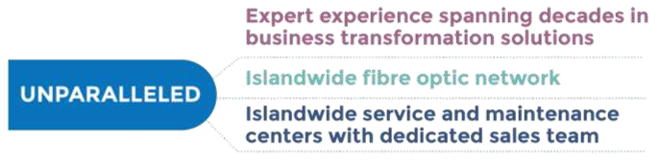

The company's widespread presence across the island, with regional telecommunication offices, Teleshops, and an extensive dealer and reseller network, ensures that customers, irrespective of their location, can easily access its services. This extensive reach benefits a vast array of customers ranging from domestic users, SMEs, and retail customers to multinational corporations, enterprises and public sector institutions.
Drawing upon its legacy of 165+ years, SLT-MOBITEL is ready to meet the challenges of the Nation’s digitalization process and the emerging digital economy head-on. It has strengthened its commitment to providing lifestyle services to customers and delivering world-class platforms and solutions to enterprises. By leveraging this wealth of experience, SLT-MOBITEL continues to offer unparalleled solutions, perfectly poised to revolutionize the SME sector and drive its participation in the global digital economy.

ENTERPRISE BUSINESS PROPOSAL

OUR STRENGTHS

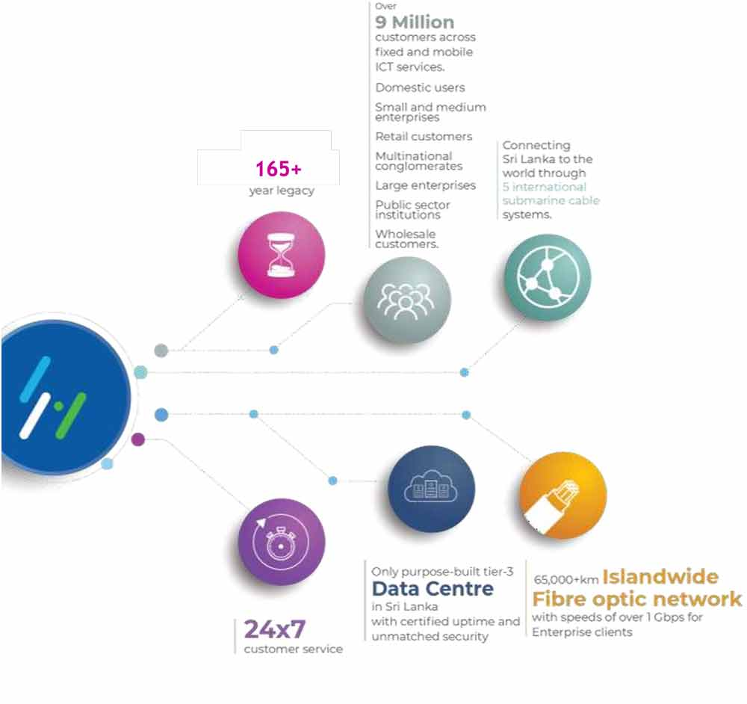

ENTERPRISE BUSINESS PROPOSAL

WHY WITH US

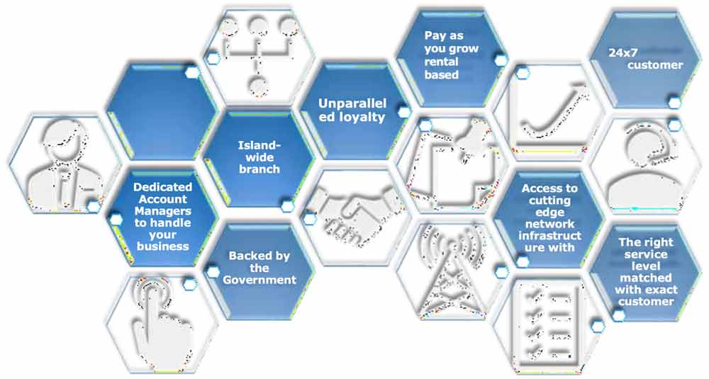

ENTERPRISE BUSINESS PROPOSAL
Proposal Ref. No. 1-SDERFS

YOUR REQUIREMENTS

Uninterrupted Internet connectivity for head office with dedicated IP

ENTERPRISE BUSINESS PROPOSAL
Proposal Ref. No. 1-SDERFS
PROPOSED SOLUTION


After careful study on your requirement, we have designed following solutions for your requirements. Total solution includes following components.

Service | Station | Access Media | Network Terminating Unit (NTU)
BIL | Malabe | Fibre | Layer 3 Cisco Router

NETWORK ARCHITECTURE

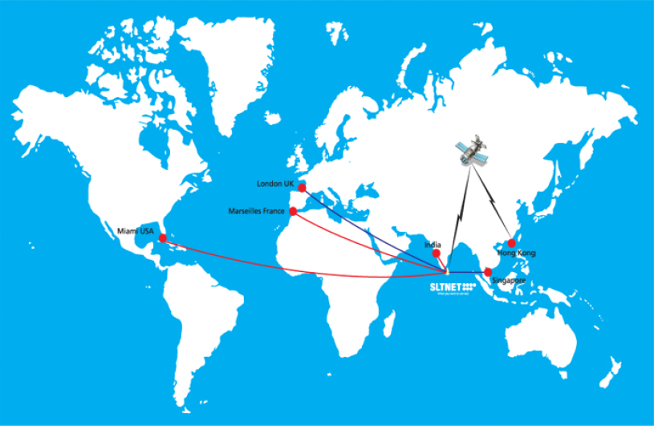

SOLUTION DIAGRAM

ENTERPRISE BUSINESS PROPOSAL
Proposal Ref. No. 1-SDERFS

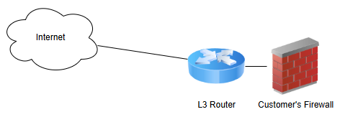

ENTERPRISE BUSINESS PROPOSAL
Proposal Ref. No. 1-SDERFS

YOUR INVESTMENT

Description | Speed/Bandwidth | One Time Charge (LKR) | Monthy Rental without Taxes (LKR)
Business Internet Line_BWB | 10Mbps | 100,000.00 | 150,000.00

*Note

* 1 Year commitment period will be applicable

ENTERPRISE BUSINESS PROPOSAL
Proposal Ref. No. 1-SDERFS


TERMS & CONDITIONS

- All quoted prices are valid for 30 days period from the date of submission of the proposal unless extending in written notice.
- The quoted prices will be subjected to prevailing applicable taxes.
- Since this is a budgetary quotation, do not make any payment against this quotation please.
- Information contained in this proposal should not be disclosed outside Blue Beach Hotel and shall not be duplicated, used or disclosed to any unauthorized party.
- Provisioning of services will be provided within 30 days from the confirmation on customer readiness and receipt of technically and commercially cleared order.
- Any future service expansions /changes for existing setup will be made at cost: subject to scope of work.
- No hidden charges, maintenance fee other than the above offer.
- Customer shall provide the copy of business registration.
- Required LAN IP plan has to be submitted by the customer at the time of service request

ENTERPRISE BUSINESS PROPOSAL
Proposal Ref. No. 1-SDERFS

CUSTOMER ACKNOWLEDGEMENTS

Regional Enterprise Business Manager
Sri Lanka Telecom PLC
WPC2 [REBM AREA]

Dear Sir/Madam,

We hereby confirmed our acceptance of the proposal submitted on 08 AUG 2025 under Proposal reference number, 1-SDERFS

Company Name : ………………………………………………………………….
Address : ………………………………………………………………….

Solution : ………………………………………………………………….

Initial & Monthly Charges : ………………………………………………………………….

Commitment Period : ………………………………………………………………….

…………………………………… ……………………
Signature Date

ENTERPRISE BUSINESS PROPOSAL

SME SOLUTIONS


COMMUNICATION
Ability to stay connected with your customers and provide prompt responses are key aspects of customer service to ensure no business opportunity is missed. It is important that both internal and external communication channels are organised to achieve this, and we offer a range of communication solutions from voice to messaging over fixed and mobile to help streamline communication.

DATA HOSTING, STORAGE & SECURITY
Fuel your business growth with SLT-MOBITEL's bespoke services from our purpose-built Tier III data centre, recognized by the Uptime Institute. Our "Gold Rated" facility, certified by the Green Building Council of Sri Lanka, aligns with your diverse business requirements, while championing environmental sustainability.

NETWORKING SOLUTIONS
A wide range of networking solutions to connect your business to the highest levels of security and reliability at the fastest speeds. With multiple access modes, we can provide you with multiple high- bandwidth solutions for both internet access and Private Network Connections.

IoT SOLUTIONS
Unleash the power of connectivity with our IoT solutions. Transform your business operations with real-time data, enhanced efficiency, and smart automation. From device integration to data analytics, we bridge the gap between your business and the digital world.
Experience the future of intelligent business today with our IoT solutions.

SOFTWARE DEVELOPMENT
Stay up to date with new tech solutions in today's competitive market with SLT-MOBITEL’S affordable, dependable, and tailor-made Software Solutions. Propel your business to new heights in your niche, leveraging our unmatched technological expertise.

MARKETING SOLUTIONS
Maximise your brand's reach engaging your target audience through marketing efforts that deliver impactful results. Leverage our comprehensive targeting capabilities and data-driven insights. Drive brand awareness, increase conversions, and stay ahead in the digital marketing landscape with SLT-MOBITEL.

ENTERPRISE BUSINESS PROPOSAL

AWARDS AND ACCOLADES

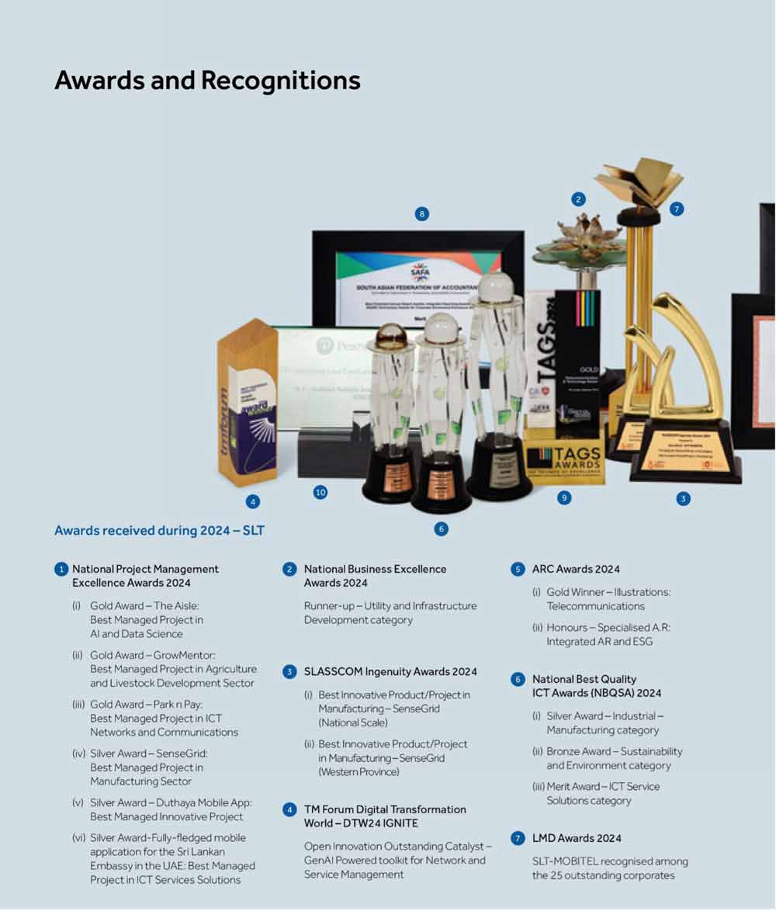



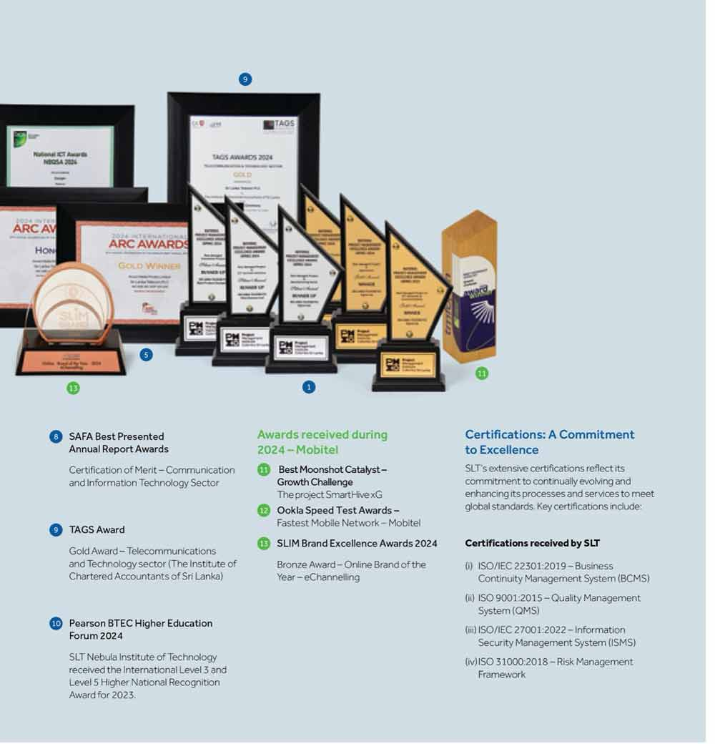

ENTERPRISE BUSINESS PROPOSAL
Proposal Ref. No. 1-SDERFS
CONTACT US
fshndgjfgjghkghkghkjggxfvxcvcvxvxzS

Please contact us for all your inquiries. We are more than happy to help you!

Primary Contact

Name:
Designation: Enterprise Account Manager
Contact Number: 0718765467
Email: samith@slt.com.lk
Division: REBM WPC 2

Secondary Contact

Name:
Designation: | Regional Enterprise Business Manager
Contact Number: | 0718765456
Email: | amila@slt.com.lk
Division: | REBM WPC 2

Other Contacts





Telephone: 0112 389 389
WhatsApp: 070 500 4000
E-mail: bizsolutions@slt.com.lk
Website: www.bizleads.slt.lk




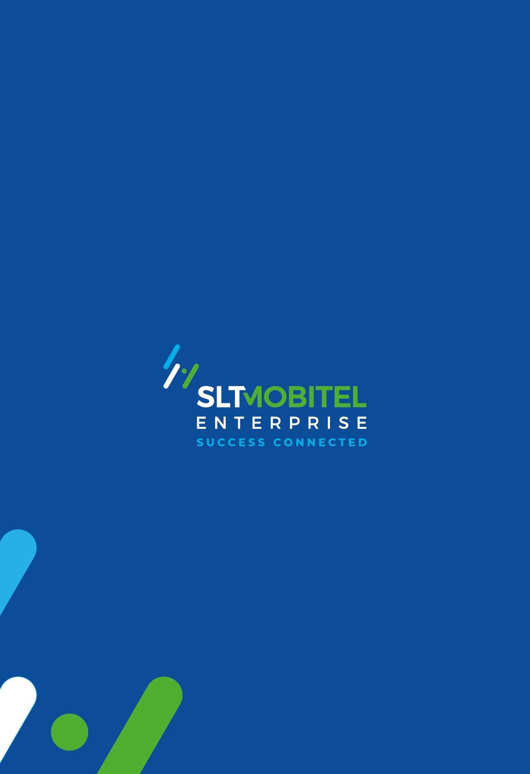
ENTERPRISE BUSINESS PROPOSAL
fshndgjfgjghkghkghkjggxfvxcvcvxvxzS

16

